Computer Networks
ASSIGNMENT 3 – CO3
Name | S. Sarah Khan | Register No. | 1965260116
Submission Date | 16-11-2026 | Course | Computer Networks (CSA0708)
GitHub Repository | https://github.com/Sarah270809/CSA0708-computer-networks | Nature / Duration | Individual / 1 Week
Simulation Tool | Cisco Packet Tracer / Python 3 | Total Marks | 50

CO3: Analyse and compare the performance of core network protocols such as TCP, UDP, HTTP and DNS under varying conditions – multiplexing and demultiplexing, TCP, UDP, sockets, congestion control, quality of service, queuing models, traffic management, QUIC and TLS 1.3.
Assignment Title: Performance Analysis and Comparison of Core Network Protocols
Nature of Assignment: Individual
Duration: 1 Week
Simulation Tool: Cisco Packet Tracer (with Python 3 for every “Complete the Code” program)
Bloom’s Level Assessed: K5 – Evaluate
Submission Date: 09-11-2026
Note: Add the working GitHub repository URL after creating the required repository.

Q1 – Which Socket Gets the Segment?
1. Socket receiving each segment
Arriving segment | Receiving socket / result
TCP 49.37.2.8:50001 → server:443 | Established TCP socket for 49.37.2.8:50001.
TCP 117.96.4.2:50000 → server:443 | Established TCP socket for 117.96.4.2:50000.
TCP SYN 106.51.7.7:41000 → server:443 | TCP listening socket on port 443 accepts the new connection.
UDP 49.37.2.8:50000 → server:5004 | UDP socket bound to port 5004 receives the datagram.
2. Why TCP can reuse source port 50000: A TCP connection is identified by the four-tuple (source IP, source port, destination IP, destination port). Different client IP addresses therefore create different connections even if both use source port 50000. A UDP socket bound to port 5004 receives datagrams through the same local socket; the application can inspect the sender address returned by recvfrom(), but the local port alone does not identify each viewer.
3. Header overhead for a 100-byte payload (IPv4): IPv4 header = 20 bytes; UDP header = 8 bytes; TCP header = 20 bytes (minimum, without options). UDP total = 128 bytes, overhead = 28/100 × 100 = 28%. TCP total = 140 bytes, overhead = 40/100 × 100 = 40%.
4. Protocol choice: Scores and ball-by-ball commentary should use TCP/HTTPS because correct order and reliable delivery matter. Live video can use UDP-based RTP/WebRTC because low delay is more important than retransmitting late packets; limited packet loss is preferable to freezing.
5. Complete the code – UDP and TCP socket server/client:
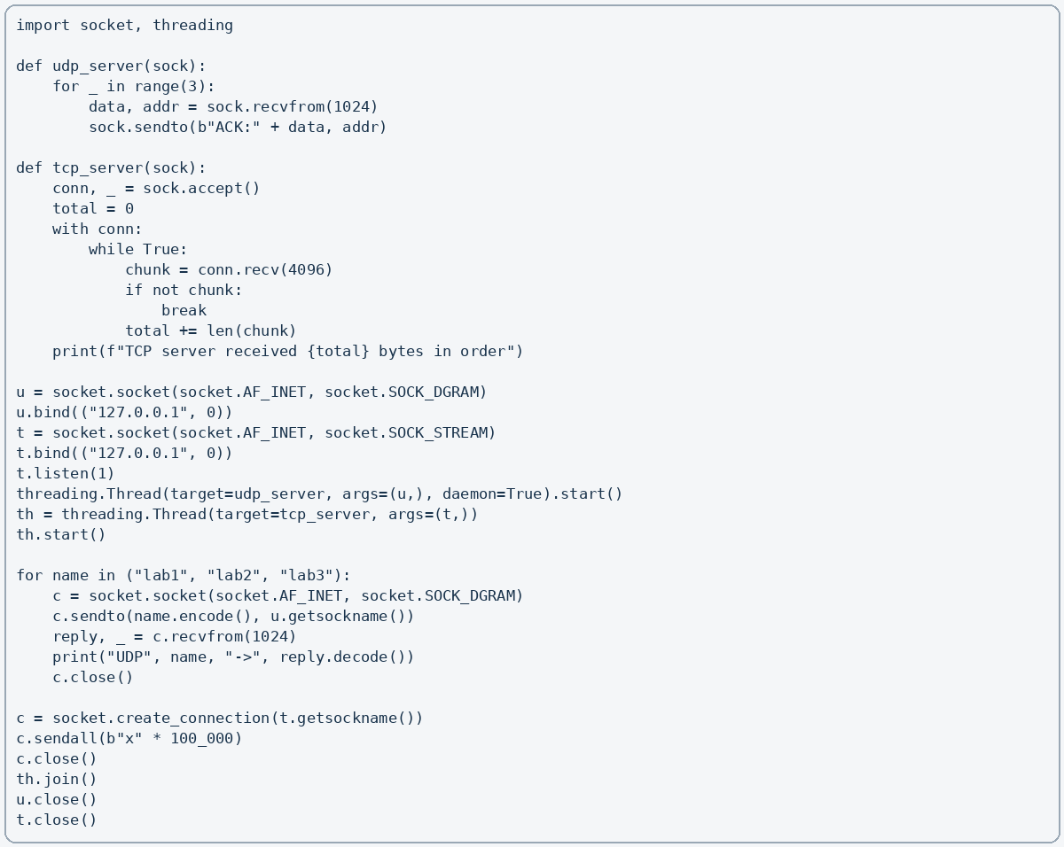
Expected output: UDP lab1 → ACK:lab1; UDP lab2 → ACK:lab2; UDP lab3 → ACK:lab3; TCP server received 100000 bytes in order.
6. Experimental evidence: Capture loopback traffic in Wireshark. TCP shows SYN, SYN-ACK and ACK, followed by sequence and acknowledgement numbers. UDP shows datagrams without a handshake. Test 1%, 5% and 10% loss: TCP retransmits lost data and preserves delivery order but delay rises; UDP does not retransmit automatically, so some datagrams are lost.
7. Conclusion and alternative: UDP is not unsuitable; it is appropriate when timeliness is more important than perfect delivery. If video used TCP, 2% loss at 500 packets/s means about 10 lost packets per second. At least one 60 ms RTT may be needed per loss recovery, so freezes can occur up to about 600 lost-packet events per minute (10 losses/second × 60) in a simple estimate. Actual freezes depend on congestion control, buffering and packet-loss bursts.

Q2 – Read the Congestion Window
1. Congestion-window interpretation: The supplied graph indicates growth during slow start, then congestion avoidance. At a loss, ssthresh is set to approximately half the current cwnd. A sharp fall to 1 indicates Tahoe-style recovery; a fall to about half indicates Reno fast recovery.
2. ssthresh and loss events: From the stated loss points, ssthresh is recalculated as max(cwnd // 2, 2). At RTT 8, the window before loss is about 19 segments, so ssthresh ≈ 9. At RTT 14, use half of the window immediately before that loss (about 13–14 segments), giving ssthresh ≈ 6–7. Exact values depend on whether the graph records the window before or after loss.
3. Tahoe or Reno: The trace that reduces cwnd to 1 after loss is TCP Tahoe. Reno reduces cwnd to roughly half and continues from that value. The assignment’s supplied trace should be checked against this rule.
4. Throughput at RTT 7: cwnd = 18 segments (RTT 7); segment size = 1,460 bytes; RTT = 0.04 s. Throughput = (19 × 1,460 × 8) / 0.04 = 5,548,000 / 0.04? Correctly, 18 × 1,460 × 8 = 210,240 bits; 210,240 / 0.04 = 5,256,000 bit/s = 5.256 Mbps.
5. AIMD fairness: Additive increase gives each flow a similar increase, while multiplicative decrease reduces both windows by a common fraction. Repeated cycles tend to move competing flows toward a fair share, assuming similar RTTs and conditions.
6. Complete the code – Tahoe and Reno simulation:
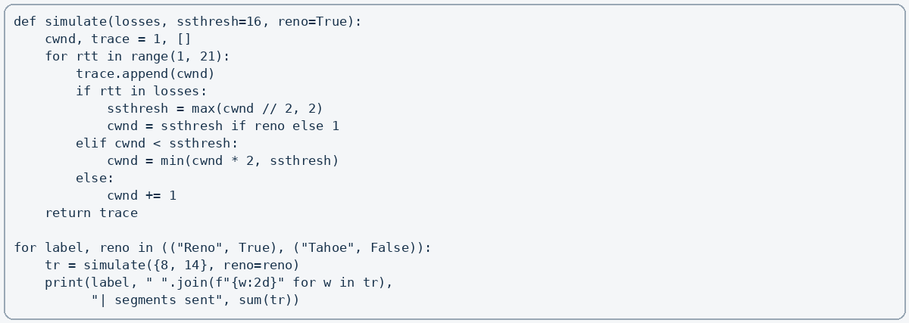
The program records the congestion window for 20 RTTs and sums the window values as an estimate of segments sent. Reno generally sends more segments than Tahoe after the same loss because it avoids restarting from cwnd = 1.
7. Experimental investigation and decision: Plot both traces; compare sums; run two iperf3 flows and inspect ss -ti. CUBIC is commonly suitable for high-bandwidth, long-distance links; BBR can achieve better throughput where random loss is not congestion by estimating bandwidth and RTT. Under 1% random loss, Reno may reduce its window unnecessarily, while BBR is less directly loss-driven. Choose after measuring delay, loss and throughput.

Q3 – Why Does the Home Page Take 8 Seconds?
Given: 1 HTML file + 80 small objects = 81 objects; RTT = 50 ms = 0.05 s; transmission time is negligible.
1. Non-persistent HTTP, one connection at a time: Each object needs about 2 RTTs (one to establish TCP and one for request/response). Total = 81 × 2 × 50 ms = 8,100 ms = 8.1 s.
2. Persistent HTTP/1.1 without pipelining: One TCP setup costs 1 RTT, then each of 81 request/response exchanges costs 1 RTT. Total = (1 + 81) × 50 ms = 4.1 s.
3. Persistent HTTP/1.1 with pipelining: One TCP setup + one RTT for the HTML + one RTT to pipeline the 80 object requests (idealised) = 3 RTT = 150 ms. This assumes responses can be delivered without significant blocking.
4. Six parallel non-persistent connections: The 80 objects are fetched in ceil(80/6) = 14 batches after the HTML. Approximate time = 2 RTT for HTML + 14 × 2 RTT = 30 RTT = 1.5 s. This simplified estimate assumes six simultaneous connections and negligible transfer time.
5. HTTP/2 and HTTP/3: HTTP/2 multiplexes streams over one TCP connection, but packet loss can block delivery of later TCP bytes (TCP head-of-line blocking). HTTP/3 uses QUIC over UDP; independent streams avoid transport-level head-of-line blocking between streams.
6. Cache headers: Cache-Control can allow fresh objects to be reused without a network request. ETag enables conditional requests; if unchanged, the server replies 304 Not Modified, avoiding retransmission of the object body. A fully fresh cached page may load with near-zero network object-fetch time; exact saving depends on cache policy and validation RTT.
7. Engineering decision: Prioritise caching/static asset reuse, reduce the number of objects through bundling, and use HTTP/2 or HTTP/3. Measure each change in browser developer tools at 0, 50 and 200 ms added delay.
8. Alternative – bundle 80 objects into 8: Total objects become 9 including HTML. Non-persistent sequential HTTP = 9 × 2 × 50 ms = 0.9 s. Persistent HTTP/1.1 without pipelining = (1 + 9) × 50 ms = 0.5 s. Bundling greatly reduces request/connection overhead; HTTP/2 can further improve multiplexing and connection efficiency.

Q4 – How Many Queries Reach the University’s DNS Server?
1. Queries per hour from one resolver: With TTL 300 s, refreshes per hour = 3,600/300 = 12 queries/hour. With TTL 30 s, = 3,600/30 = 120 queries/hour.
2. Why resolver count and TTL matter: Students using the same ISP resolver share its cached answer. Therefore, authoritative query volume depends mainly on the number of distinct resolvers and how often their cached records expire, not directly on the number of students.
3. Recursive vs iterative query: A phone sends a recursive query to its configured resolver and expects a final answer. The resolver performs iterative lookups: root server → .in TLD server → ac.in authoritative delegation → simats.ac.in authoritative server, then returns the address to the phone.
4. Required records: A maps the host to IPv4; AAAA maps it to IPv6; CNAME provides an alias if needed; MX identifies mail servers; NS identifies authoritative name servers; TXT stores verification and policy information such as SPF. DNS commonly uses UDP for small queries; TCP is used for zone transfers and responses too large or truncated for UDP.
5. Long TTL risk: A long TTL reduces query load but keeps old addresses cached. If the result server moves during result day, users may continue contacting the old IP until the TTL expires.
6. Complete the code – iterative DNS resolution:
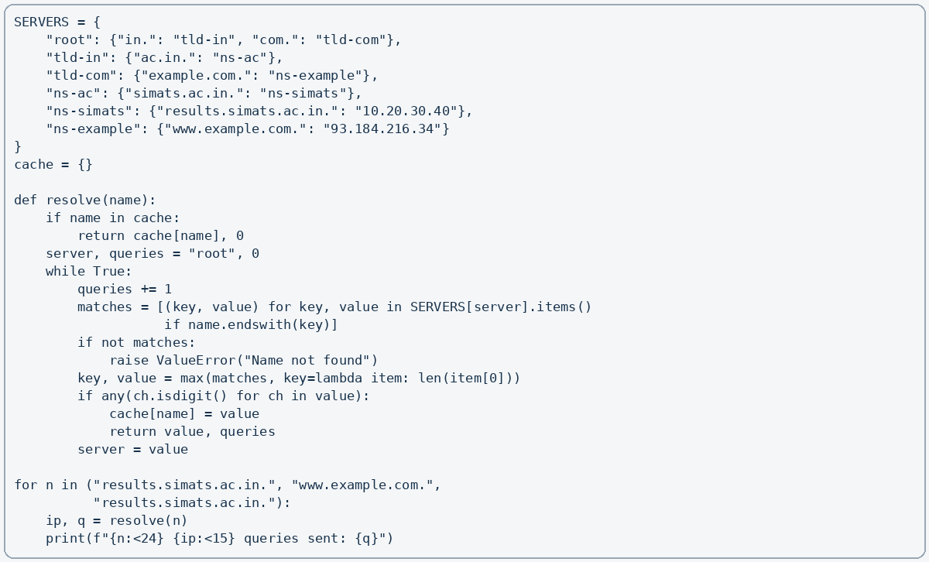
Expected output: results.simats.ac.in. → 10.20.30.40 (4 queries); www.example.com. → 93.184.216.34 (3 queries); repeated results lookup → 0 queries because it is cached.
7. TTL and CDN decision: Use a moderate TTL before result day and lower it in advance of a planned migration. A CDN with anycast DNS directs users to a nearby edge location; most DNS queries are handled by recursive resolvers and CDN DNS infrastructure, so fewer need to reach the university’s own authoritative server. Distant users may get lower lookup and content-delivery delay.

Q5 – When Will the Video Call Freeze?
Given: service rate μ = 1,000 packets/s. M/M/1 formulas: utilisation ρ = λ/μ; average packets L = ρ/(1−ρ); average time in system W = 1/(μ−λ).
Arrival λ (pkt/s) | ρ | L (packets) | W (ms)
500 | 0.50 | 1 | 2
800 | 0.80 | 4 | 5
900 | 0.90 | 9 | 10
950 | 0.95 | 19 | 20
990 | 0.99 | 99 | 100
1000 | 1.00 | Unstable | Unbounded
1. Delay threshold: At 950 packets/s, average delay is exactly 20 ms; it first exceeds 20 ms above 950 packets/s. Delay rises sharply near capacity because μ−λ becomes very small.
2. Load comparison: At λ = 450, W = 1/(1000−450) = 1.818 ms. At λ = 900, W = 1/(1000−900) = 10 ms. This is about 5.5 times, not ten times. (The exact tenfold comparison in the question is an approximation or may refer to another baseline.)
3. Token bucket: Bucket size = 1 MB = 8 Mb. Backup rate = 10 Mbps; permitted average = 2 Mbps. Excess rate = 8 Mbps. Burst duration = 8 Mb / 8 Mbps = 1 second before tokens are depleted; thereafter traffic is limited to the configured rate.
4. DiffServ: EF for real-time voice/video; AF for important controlled traffic such as business applications; best effort for ordinary browsing and background backup. Backup should be shaped so it does not dominate the link.
5. Complete the code – M/M/1 queue:
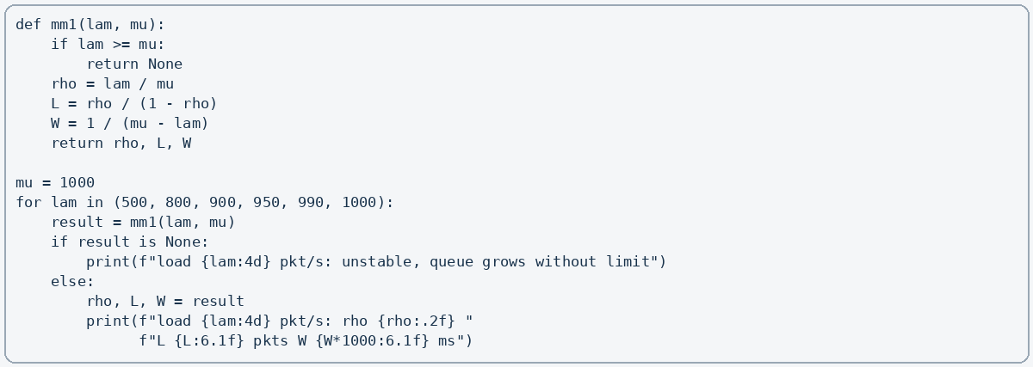
6. Link capacity for delay below 10 ms at λ = 1,500: W = 1/(μ−1500) < 0.01 s. Therefore μ−1500 > 100, so μ > 1,600 packets/s. Minimum integer capacity is 1,601 packets/s.
7. Alternative: Double capacity to μ = 2,000 with λ = 1,800 gives W = 1/(200) = 5 ms. On the old link, strict priority may protect video from backup delay, but it cannot create extra capacity and can starve lower-priority traffic. Configure QoS and shape backup; upgrade the link if total demand regularly approaches capacity.

Q6 – Count the Round Trips Before the First Byte
Given: RTT = 100 ms. The values below count handshake round trips before application request data can be sent; exact timing can vary with implementation and whether DNS is included.
Connection method | Approx. RTTs | Time before request data
TCP + TLS 1.2 | 3 RTT | 300 ms
TCP + TLS 1.3 | 2 RTT | 200 ms
QUIC, first visit | 1 RTT | 100 ms
QUIC with 0-RTT resumption | 0 RTT | 0 ms (early data can be sent immediately)
1. Replay risk: 0-RTT data may be replayed because early data is sent before the new handshake is fully completed. An attacker may cause the same early request to be processed more than once. Never send non-idempotent actions such as money transfers, payments, account changes or order submissions as 0-RTT. Use it only for safe, replay-tolerant requests.
2. QUIC connection migration: QUIC uses a connection ID that is not tied only to the phone’s IP address and port. When the phone changes from Wi-Fi to 5G, QUIC can validate the new path and continue the connection. A TCP connection is identified by its endpoint address/port pair, so a path change normally breaks it and requires a new connection.
3. Firewall issue and fallback: Some firewalls block UDP traffic or specifically block QUIC. The app/browser should fall back to HTTP/2 over TCP with TLS 1.3 when QUIC cannot connect.
4. TLS 1.3 investigation: In Wireshark identify ClientHello, ServerHello, EncryptedExtensions, Certificate (when sent), CertificateVerify and Finished. Use openssl s_client to inspect supported TLS versions and browser developer tools to check HTTP/3.
5. Conclusion: QUIC is suitable for the banking app because it reduces setup delay and supports connection migration. Use TLS 1.3 security, disable 0-RTT for financial state-changing operations, and retain TCP/TLS fallback.
6. Alternative during Wi-Fi-to-5G switch: TCP + TLS 1.3 generally needs a new TCP connection and TLS handshake (about 2 RTT = 200 ms, excluding DNS). QUIC may migrate the existing connection after path validation, typically avoiding a full new TLS handshake; allow roughly one RTT (100 ms) for validation in a conservative estimate. Over a 30-second transfer, this reduces interruption, but exact loss depends on network conditions.

Q7 – Choose the Protocols from First Principles
Stage 1 – Interpret the problem
Traffic type | Main requirements
Live video consultation | Very low delay and jitter; tolerate small losses; secure media.
Patient records / X-rays | Reliable, ordered, complete delivery; confidentiality and integrity.
Chat | Reliable, ordered messages; low delay; secure.
Hospital service lookup | Fast name resolution; caching; accurate records.
Measurable targets: aim for conversational video delay below about 300 ms where possible, low jitter, and prioritised media; deliver every medical file with integrity verification; encrypt all patient data in transit; resolve service names quickly using cached DNS.
Stage 2 – Compare candidate protocols
Protocol | Best use / evaluation
TCP | Reliable ordered byte stream; suitable for files and chat, but loss can increase delay.
UDP | Low overhead and no built-in retransmission; suitable for real-time media with application-level loss handling.
QUIC | UDP-based secure transport with multiplexed streams and connection migration; useful on changing mobile links.
HTTP/2 | Multiplexes requests over TCP; efficient but TCP loss can stall all streams.
HTTP/3 | HTTP over QUIC; independent streams reduce transport head-of-line blocking.
TLS 1.3 | Provides encryption, authentication and integrity; use with TCP or QUIC.
TCP throughput limit: Window = 64 KB = 65,536 bytes (using 64 KiB); RTT = 0.3 s. Throughput ≤ window/RTT = 65,536/0.3 = 218,453 bytes/s ≈ 1.75 Mbps. This can make large X-ray transfers slow; window scaling, larger receive windows, or QUIC can improve performance.
DNS and QoS: Publish A/AAAA and required NS/CNAME records; use a caching recursive resolver and sensible TTL. Mark real-time voice/video as EF, important interactive records/chat as AF where appropriate, and background bulk transfers as best effort or shaped traffic.
Stage 3 – Implement and verify: Use TCP sockets for reliable file transfer and chat. Verify file size and a checksum at the receiver. Test with delay and packet loss using tc netem or a simulator. Record transfer time, throughput, message delivery, video delay and packet loss. UDP media should use sequence numbers, timestamps, jitter buffering and selective concealment/recovery.
Stage 4 – Defend the design: Use UDP/QUIC-based media for low-latency consultation, TCP or QUIC reliable streams for records and chat, HTTPS with TLS 1.3 for protected web services, and DNS caching for service lookup. With 5G, lower RTT and higher bandwidth improve quality, but encryption, congestion control, QoS and reliable file delivery remain necessary.
Alternative commercial service – Questions and decision: Ask for measured end-to-end latency, jitter, packet loss tolerance, adaptive bitrate behaviour, uptime/SLA, encryption, key management, data residency, access controls, audit logs, retention/deletion policy, breach response and compliance evidence. Choose it only if independent tests and contractual evidence show acceptable clinical quality and strong protection of patient data.
Overall conclusion: A hybrid design is best. Match each protocol to the application’s delay, reliability and security needs, then validate it under the stated 100–300 ms RTT and up to 5% loss.

